**Developed by**

1. Mindy Atikah Chiara Gyver
2. Nurul Awalia Rehania



**PROJECT ON**

Webteen

**Webteen**

Batch Code : 3SC5

Start Date : th, 2018

End Date : June 4th, 2018

Name of Coordinator : Fachran Nazarullah

Name of Developer : Mindy Atikah Chiara Gyver

Nurul Awalia Rehania

Date of Submission : May 5th, 2018

**CERTIFICATE**

This is to certify that this report, titled *Webteen,* embodies the original work by *Mindy Atikah Chiara Gyver, Nurul Awalia Rehania* partial fulfillment of his/her course requirement at NIIT.

Coordinator:

***Fachran Nazarullah***



**ACKNOWLEDGEMENT**

Writer have benefited a lot from the feedback and suggestions given to us by Fachran Nazarullahand other faculty members. Writer make this project to fulfill our assignment.

Writer make this project with see the comic reader read convetional comic and think it as unefficient and waste much money.

Writer said Alhamdulillah to Allah S.W.T because of his blessing, writer can complete this project.

Writer know this paper is far from perfection. Writer hope if writer friend and writer faculty give any comment and suggestion to make this paper better than before.

Writer also said thankyou to :

1. Our Family who give many support to make this paper completed.
2. Fachran Nazarullah as the guide’s lecturer that give put together with the suggestion, idea & constructive spirit to make this project better.
3. Our Friends who give many idea, spirit and comment to our project.

If the writer made a mistake in writing an *Webteen*, Writer ask forgive to all reader and listener of this paper.

Depok, May 5th 2018

**SYSTEM ANALYSIS**

**System Summary**:

A barber (from the Latin barba, "beard") is a person whose occupation is mainly to cut, dress, groom, style and shave men’s and boys' hair. A barber's place of work is known as a "barber shop" or a "barber's". Barber shops are also places of social interaction and public discourse. In some instances, barbershops are also public forums. They are the locations of open debates, voicing public concerns, and engaging citizens in discussions about contemporary issues. They were also influential in helping shape male identity.

At this time to make it easier for people searching or looking for a barbershop that near them, most barbershop creating a website so people can see the prices, services, location and more about the barbershop.

**INTRODUCTION**

In this project the author are making some website about 'Comic Online' using HTML,CSS,JavaScript, jQuery, Bootstrap, AngularJS and Github. The author is going to give the name of the comic online with the name Webteen. Webteen is a web comic reading page that provide bunch of free comic.

\

sssssssssss

**ACTIVITIES LIST**

|  |  |  |  |  |  |
| --- | --- | --- | --- | --- | --- |
| ***S.***  ***No.*** | ***Activity Description*** | ***Planned Date of Completion*** | ***Actual Date*** | ***Responsibility*** | ***Remarks*** |
| *1* | Create Layout using HTML and CSS | October 21st 2018 | October 21st 2018 | Mindy & Nurul |  |
| *2* | Create Content and Image Web | October 20th 2018 | October 23rd 2018 | Nurul |  |
| *3* | Implementing Bootstrap | October 23rd 2018 | October 23rd 2018 | Mindy & Nurul |  |
| *4* | Create Login | October 24th 2018 | October 24th 2018 | Mindy |  |
| *5* | Create Comment Coloumn | October 25th 2018 | October 25th 2018 | Nurul |  |
| *6* | Create Effect using JQuery | October 27th 2018 | May 24th 2018 | Mindy & Nurul |  |
| *7* | Create Validation using Java Script | October 28th 2018 | October 28th 2018 | Mindy |  |
| *8* | Make a Paper | October 31st 2018 | October | Mindy |  |
| *9* | Make Presentation Slide | November 1st 2018 | November 1st 2018 | Nurul |  |

**HTML PAGES**

**Home in Alegria Barbershop**

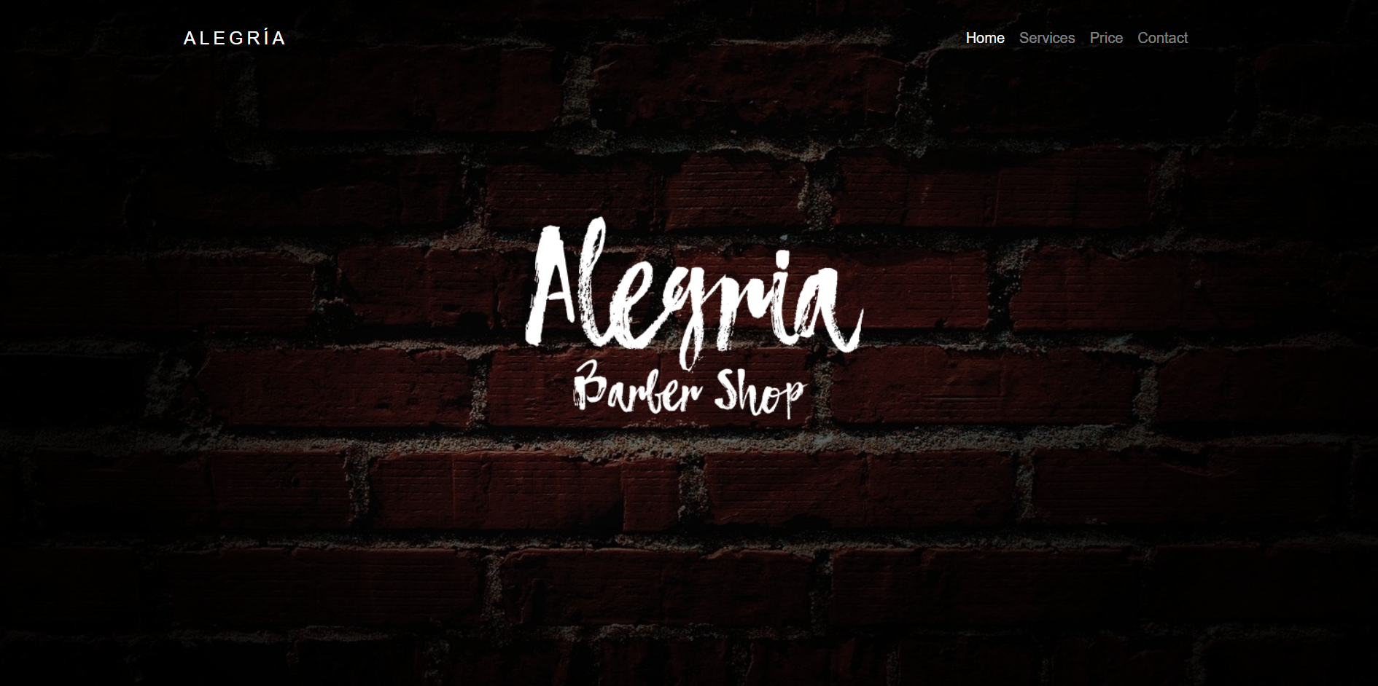

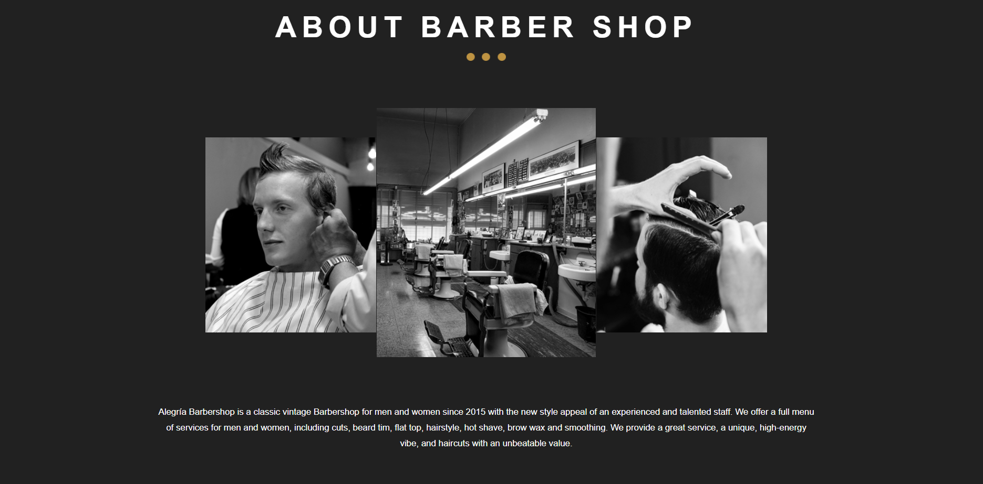

**HTML PAGES**

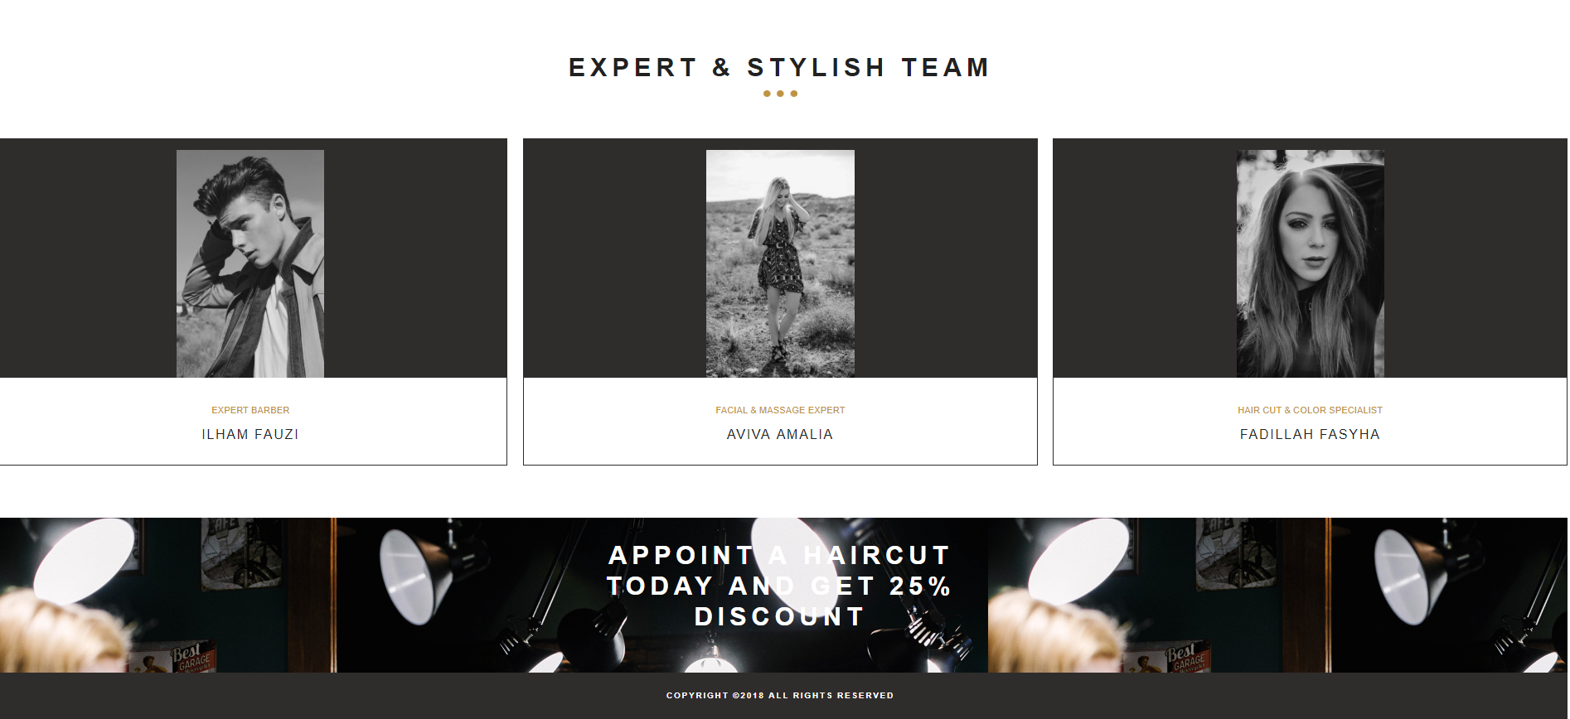

**HTML PAGES**

**Services in Alegria Barbershop**

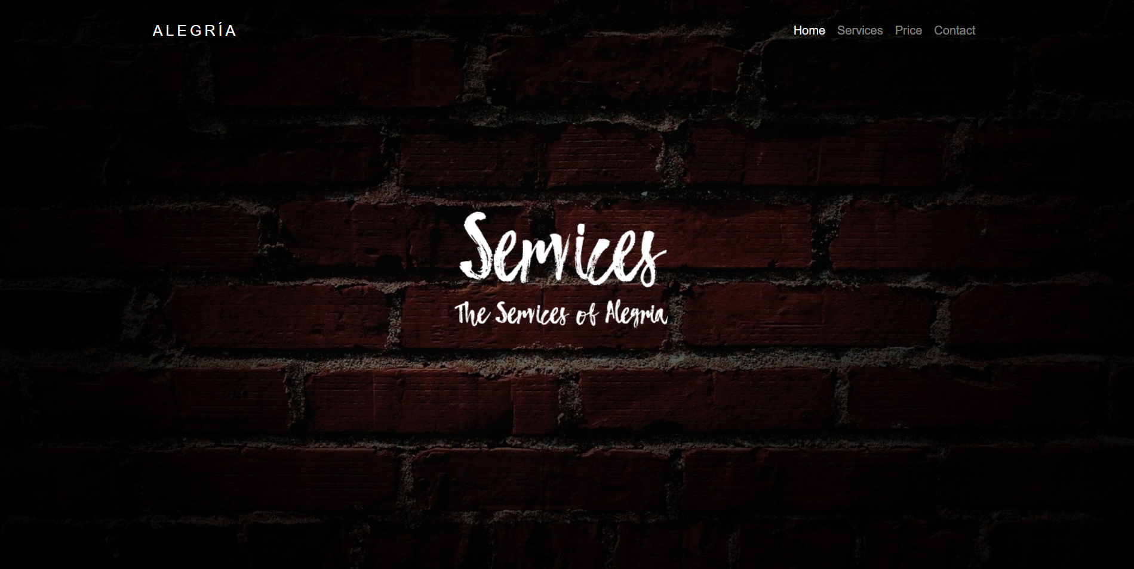

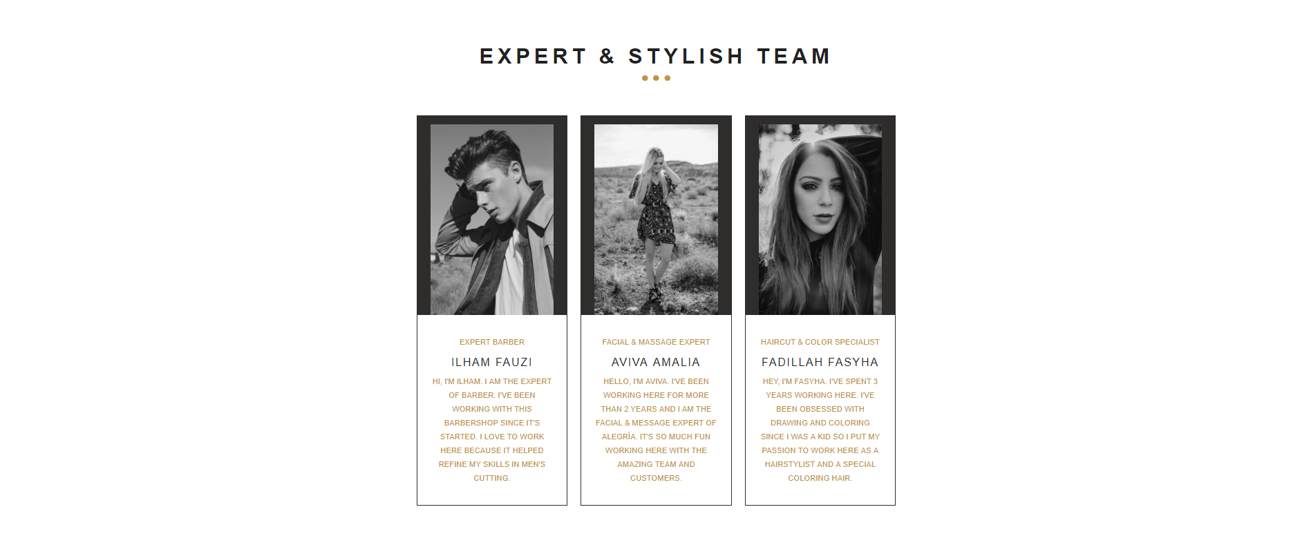

**HTML PAGES**



**HTML PAGES**

**Price in Alegria Barbershop**

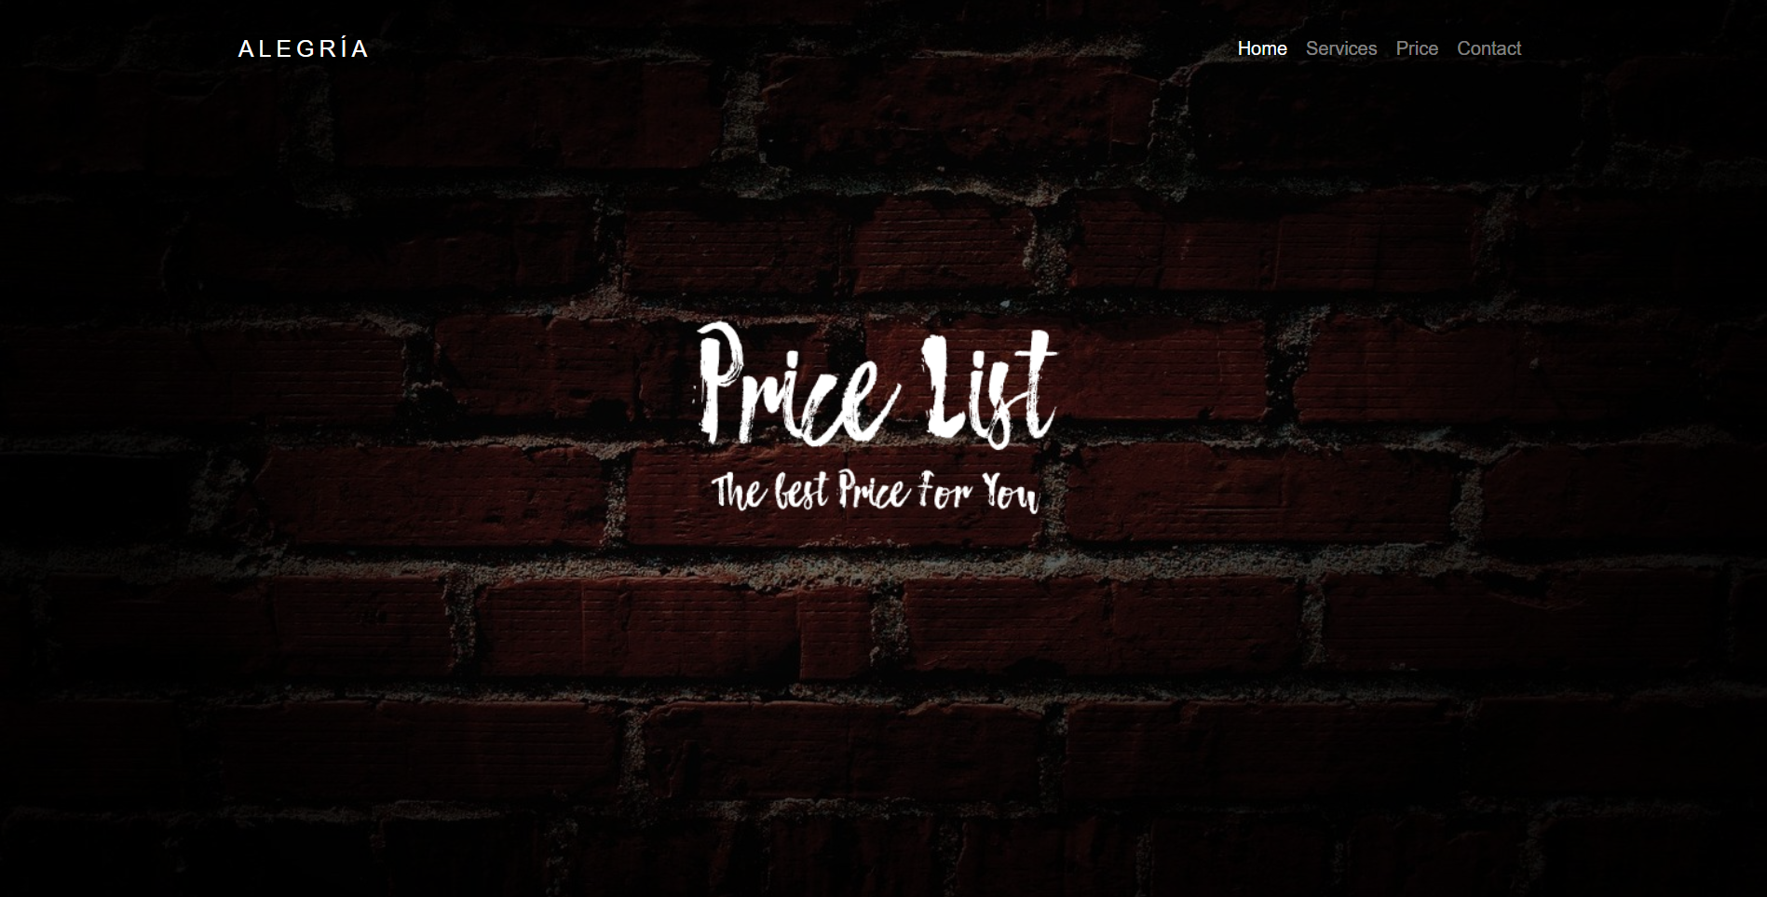

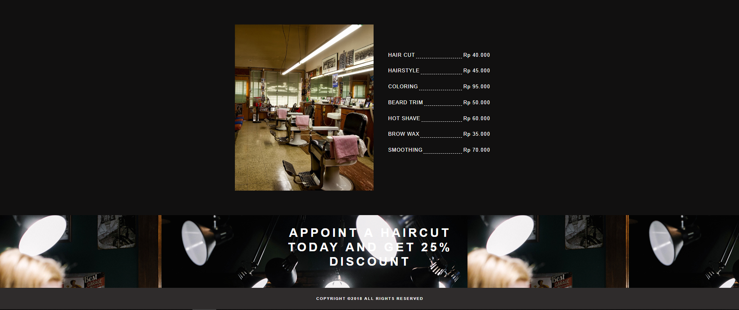

**HTML PAGES**

**Contact in Alegria Barbershop**

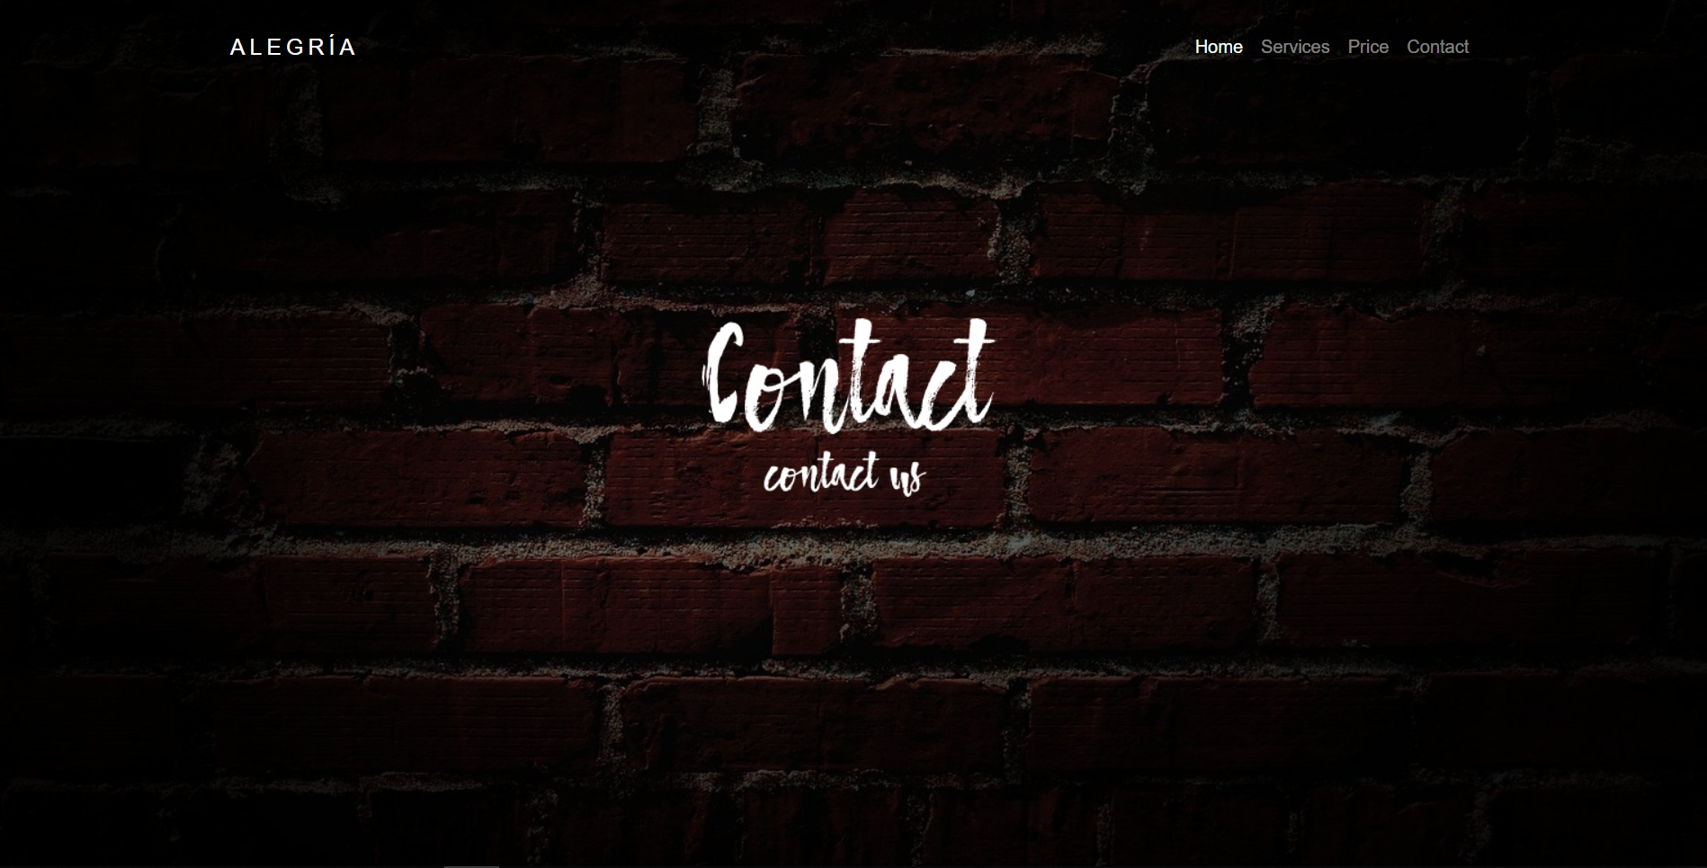

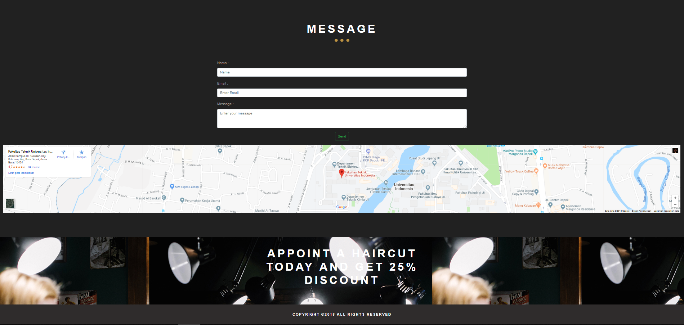

**CONFIGURATION**

**Hardware :** *Intel(R) Core(TM) i7-7700HQ CPU @ 2.80GHz (8 CPUs), 2.8GHz 500 GB HDD, ASUS X450C 802.11b/g/n,6 cell Li-ion battery*

**Operating System :** *Windows 10 Pro Education*

**Software :** Sublime Text 3.0

|  |  |  |
| --- | --- | --- |
| **PROJECT FILE DETAILS** | | |
| **S.No** | **File Name** | **Remarks** |
| 1 | Alegria Barbers Upgrade | HTML,CSS,JavaScript and jQuery |